Pokhara University

Level: Bachelor | Semester – Fall | Year : 2010
Programme: BE |  | Full Marks : 100
 |  | Pass Mark : 45
Course: Engineering Mathematics IV |  | Time : 3 hrs

Candidates are required to give their answers in their own words as far as practicable.
The figures in the margin indicate full marks.

Attempt all the questions.

1. | - Define harmonic function. Verify that 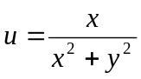 is a harmonic. Also find the conjugate harmonic function of u.  - Define simply and multiply connected region. Evaluate the integral 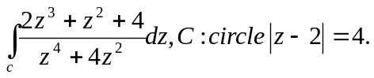  OR  State Taylor’s Theorem. Find all Taylor and Laurent series of the function 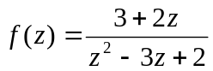 with center zero. | 7  8
2. | - Define singularity of a function. Determine the location and type of singularity of the following function including those at infinity.  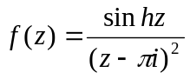.  - Define Z-transform. Find the Z-transform of the functions:  - Cosh at sinbt  - 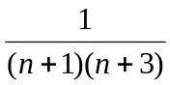 | 8  7
3. | - Find the z-transform of f(t) = e^{-iat} and hence deduce the value of Z (cosat) and Z (sinat).  - Using Z-transform, solve the following difference equation y_{k+2}+2y_{k+1}+y_{k}=k where y₀=0, y₁= 0. | 7  8
4. | - Find the solution u(x,y) of the following equation by separating variables u_{x} + u_{y} = (x+y)u.  - Solve one dimensional heat equation completely. | 7  8
5. | - Write down the Laplace equation in Spherical form and then solve it.  OR  Find the solution of the wave equation 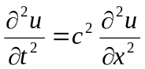 corresponding to the triangular initial deflection 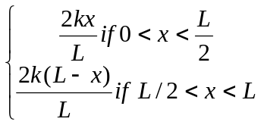  - Using Simplex method, maximize z=150x₁+300x₂ subject to the constant | 8  7
6. | - By using Fourier integral, show that 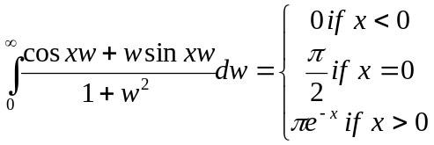  - Define Fourier Transform of a function. Fond the Fourier transform of e^{-ax2} where a>0. | 8  7
7. | - Find the residue of the function 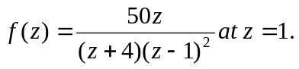  - If 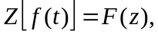then show that 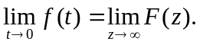  - Check the analyticity of the function f(z) = 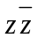.  - Find the unit tangent vector to the curve 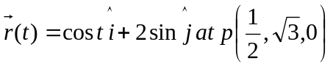  - Find the Fourier transform of the function 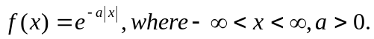 | 2×5

